Silent Mirror
I ”n AIthat helps you see yourself clearly before you decide.
Silent hlirror is not a chatbot. It is not a productivity too1. It is not a journaling app.
It is an AI that interacts with you normally — answering questions, helping you think, supporting your work — while quietly building a reflective understanding of you over time. When the patterns it observes are consistent enough, it holds them up as a gentle, tentative insight.
Not a verdict. Not a diagnosis. A mirror.

The idea
Imagine waking up in the morning and asking an AI what to focus on today. It answers helpfully. Clear, efficient, useful.
But something is different.
It does not just stop at the answer. Quietly, in the background, it begins to notice patterns. Not in a way that interrupts or judges — but in a way that observes.
After a week it says:
“1may be wrong — but it seems like yoti tend to explore ideas deeply, but sometimes struggle to act on them. Does this feel accurate?“
For the first time, the AI is not just giving answers. It is holding up a mirror.
You can agree, disagree, or ignore it completely. Nothing is forced. Nothing is fixed.
Over time, Silent Mirror becomes whatever you need — a study partner, a work assistant, or simply a space to think. But it never takes control. It only reflects.

Why the brain and why this matters
Every person carries the most sophisticated self-awareness system ever built — their own brain. The brain's default mode network processes experience in the background. Its predictive coding system builds and updates a model of the self. The hippocampus consolidates patterns into long-term memory. The prefrontal cortex regulates what gets expressed and when.
But most people cannot read what their brain has concluded about them.

Silent Mirror is built on the same four principles — made external, made visible, and made correctable.

Brain system | What It does | Silent Mirror equivalent
Default Mode | Processes experience quietly in | Observation layer — runs silently during every
Network | the background | conversation
Predictive coding | Builds a model of the self, updates on mismatch | Pattern confidence scoring — signals accumulate, contradictions weaken
Hippocampus | Consolidates patterns into long-term memory | SQLite database — impressions, summaries, journal entries
Prefrontal cortex | Regulates what gets expressed and when | The engine — voice rules that prevent reactive, diagnostic responses

The mirror moment — “does this feel accurate?“— is a deliberate prediction error. It shows the user the gap between who they say they are and what their patterns reveal. Either the system's modelupdates or the user's self-modelupdates. Either way, something becomes clearer.

This is how the brain learns about itself. Silent Mirror makes that process visible.

How it is different from other AI tools
Most AI tools are optimised for engagement. They answer questions, complete tasks, and return you as quickly as possible so you come back tomorrow.
Silent Mirror is optimised for awareness. It is not trying to keep you on the app. It is trying to help you understand yourself well enough to need it less.

Feature | OtherAI assistants | Silent Mirror
Memory | Resets each session | Builds across weeks and months
Insights | Answers what you ask | Notices what you do not ask
Approach | Gives answers | Holds up patterns
Framing | Confident and prescriptive | Tentative and correctable
Goal | Task completion | Self-awareness over time
Data | Processes and discards | Stores impressions, not transcripts
Control | AI decides the value | User always decides
Engagement model | Maximise time spent | Minimise dependency
Notifications | Engagement-driven | Pattern-driven, calm, never urgent

The deepest difference: Silent Mirror is not an AI you follow. It is an AI that helps you not follow blindly — including itself.

Core loop
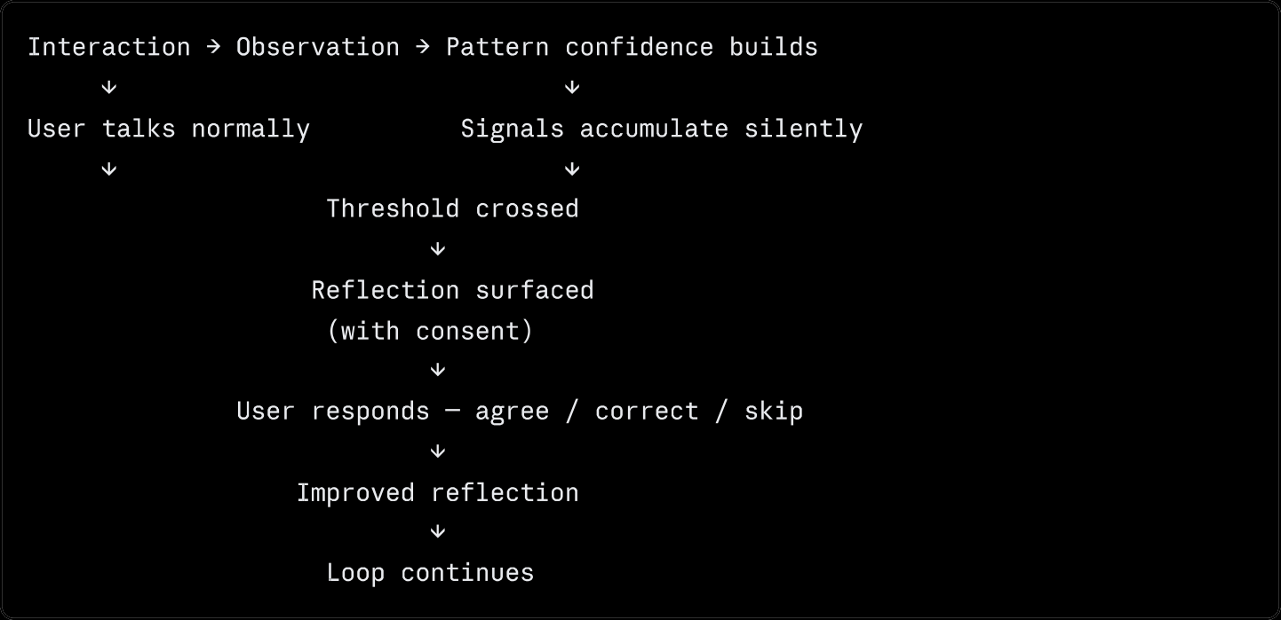
The three response paths are equal. Correcting the mirror is not a failure — it is the most valuable interaction. Every correction makes the system more accurate.

Features
Mood check-In — optional at the start of each session. One tap. Sets emotional context for everything that follows without requiring the user to explain themselves.
Silent observation — four data streams tracked automatically across every session: conversation patterns, cognitive signals, value signals, emotional signals. The user never sees this layer. It surfaces only as finished insights.
Mirror insights — surfaced at the natural close of conversations, never mid-session, always with user consent. Framed tentatively. The user responds with that tracks, not quite, or skip for now. All three are equally valid.
Journal integration — free-write entries stored with the record. Read by the observation layer. Journal entries are the most honest signal in the system — written for no audience, they reveal what conversations sometimes conceal.
Save flow — nothing is stored without the user choosing to save it. What the user saves becomes their personal record over time — study summaries, health patterns, mirror insights, growth over months.
Mode detection — ambient, never announced. The system detects from conversation context whether you are in study, health, general, or My Mirror mode. Custom modes can be created for any domain — photography, writing, music, anything.
My Mirror — the deepest mode. IQ profile, EQ profile, productivity lens, open self-work. The more the user engages, the more accurate and personal the picture becomes.

How It grows with you
In the first week, Silent Mirror is a helpfulAI with quiet observation.
After a month, it knows your patterns — what you return to, what you avoid, when you are most engaged, where the gap is between what you say and what you do.
After three months, My Mirror holds a picture of you that no other tool in your life holds — built from your own words, corrected by your own feedback, owned entirely by you.
The user does not outgrow it. It grows with them.

Technical architecture
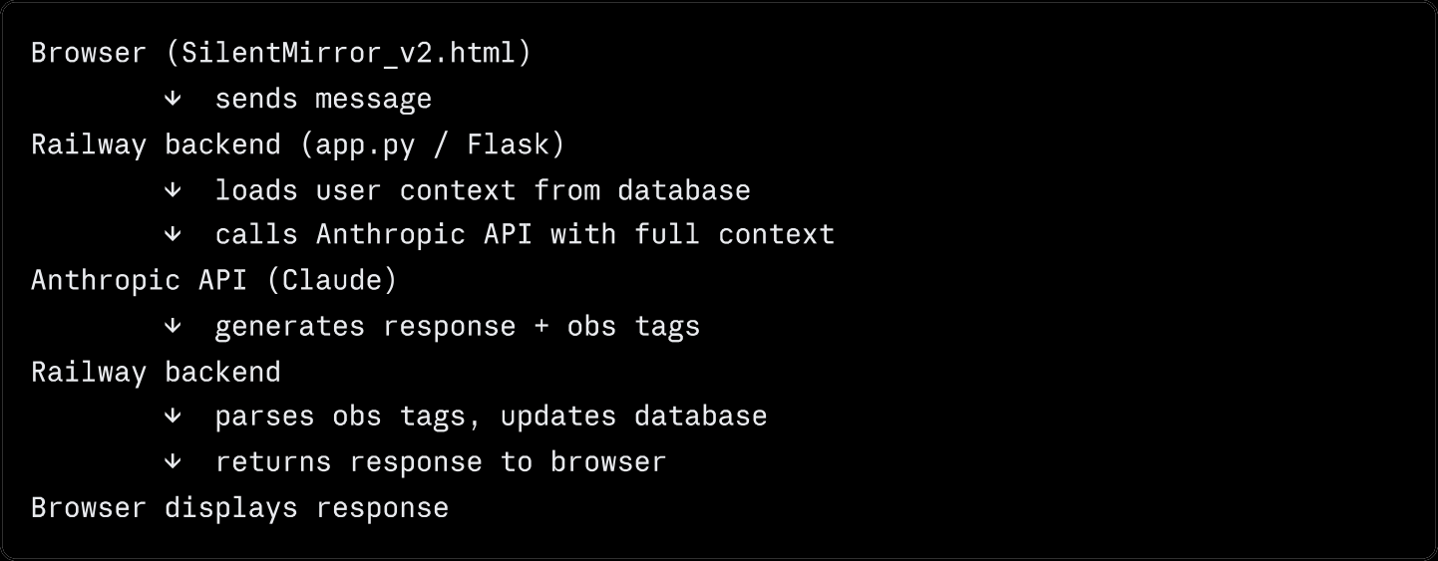
Stack:
- Frontend: Vanilla HTML, CSS, JavaScript — no framework
- Backend: Python, Flask, Flask-CORS
- Database: SQLite (8 tables — impressions, summaries, history, profile, checkins, reflection feedback, journal, users)
- AI: Anthropic API (claude-sonnet-4-20250514)
- Deployment: Railway
- Memory: Persistent across sessions via context injection (RAG pattern)

Database tables:

Table

users impressions
saved_summaries history user_profi1e checkins
ref1ection_feedback

journal
Purpose

One row per user, created on first message Pattern signals observed across sessions What the user chose to save
Last 20 messages per user for context

Running summary — dominant mode, total signals Every mood check-in submitted
Every response to a mirror insight Every journal entry written

Versions
vl— Standalone HTML Single file. Calls Anthropic API directly from browser. Requires API hey input. No persistent memory — session only. Useful for quick demos and testing the engine.
Run it: download , open in browser, enter your Anthropic API key.
app/SilentMirron vl. html
v2 — Full stack with persistent memory Flask backend on Railway. API key stored securely as environment variable — never in the browser. Full persistent memory across sessions. Check-in, journaling, reflection feedback, cross-session observation all working.
Run it: follow the deployment guide in .
/docs

Running locally
v1 — no setup required
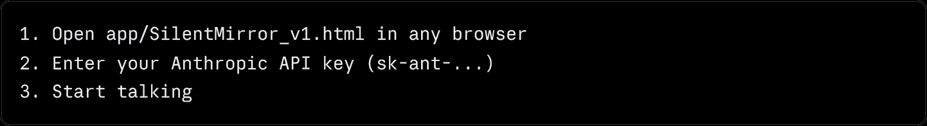
v2 — full stack
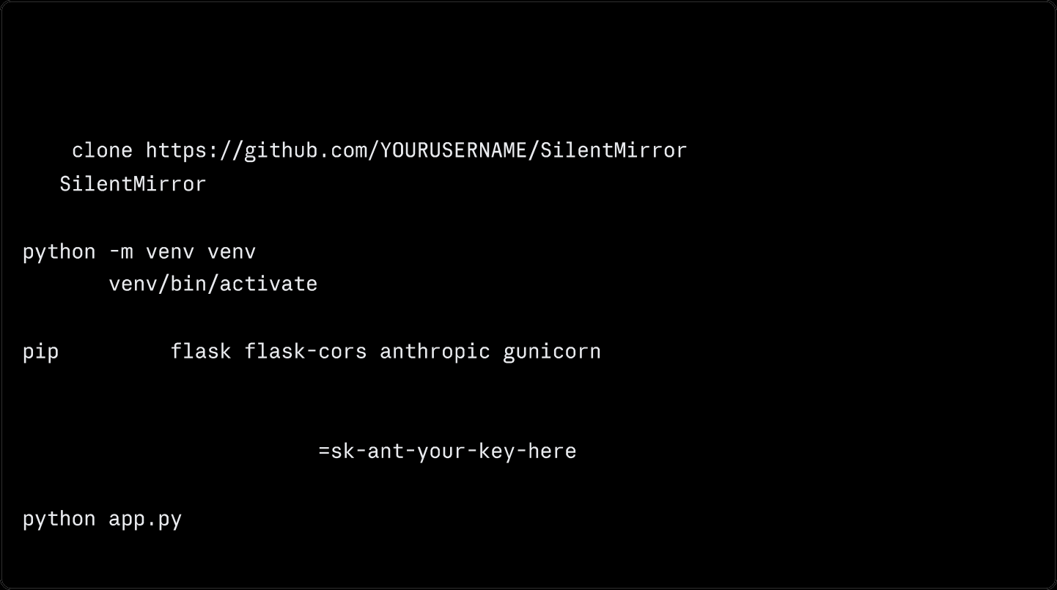
bash

# Prerequisites: Python 3.11+, Git
# hi ndows : venv\ Sc r i pI s \ac I ivat e
# Add your API key
# Backend r Unni ng at http: //127. 0. 0 . 1 : 5000

your browser — update the constant to
Then open app/SilentMirror v2. htm in
http: //127. 8. 8. 1: 5888 for local testing.
BAcKEND

Design principles
Impressions not transcripts — Silent Mirror stores synthesised patterns, not raw conversation text. The system holds what it concluded from a conversation, not the words themselves. This is both a privacy decision and a design decision.
User always decides — every insight requires consent before surfacing. Every saved summary requires the user to choose to save it. The quiz is permanently dropped if declined — no re-offering, no dormant timer. The user's decision is final.
Never diagnostic, never prescriptive — Silent Mirror never labels the user, never states certainty, and never tells the user what to do. Every insight is framed as a tentative hypothesis: I may be wrong — does this feel accurate?
Present-focused — insights describe what is happening now, not why the user is the way they are. The past is context. The present is the reflection. The future is the user's choice.
Calm voice, always — never urgent, never alarmed, never excited. The observation layer running quietly requires a quiet voice. Urgency would break the mirror.

Privacy
- Impressions stored, not transcripts — raw conversation text is processed and released
- Nothing saved without user choosing to save it
- User can view, correct, delete, or export everything the system holds
- User can pause observation at any time
- Data never sold, never shared, never used to train AI models
- Account deletion removes all data within 24 hours

Full privacy architecture in Part 10.
/docs/SilentMirron_Engine_v1_3_Final . docx

Repository structure
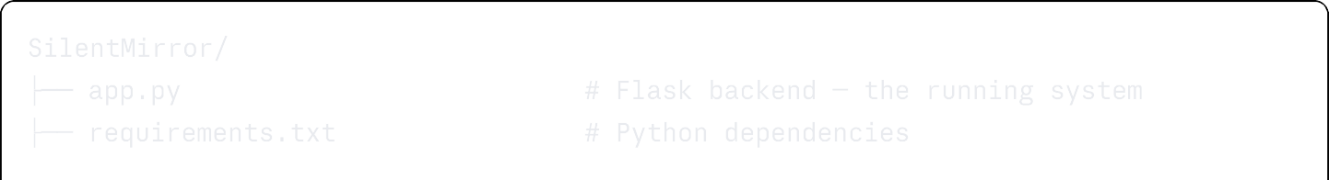

What is next
- My Mirror dashboard — visual display of what the system has observed over time
- Semantic retrieval — sentence embeddings replacing recency-based impression retrieval
- Pattern confidence classifier — small PyTorch model trained on reflection feedback
- Spaced repetition for insights — revisit affirmed insights at 1 day, 7 days, 30 days
- Wearable integration — HRV and sleep data as additional observation streams
- Decision tracking — record decisions and revisit outcomes over time

The one principle everything follows
Machines assist. Humans decide.
Silent Mirror is not ari AI you follow. It is an AJ that helps you not follow blindly — including itself
And in a world full otanswers, it quietly brings back something we often lose — the ability to
see ourselves clearly before we decide.

Built by{Your NameJ —2026 Version 2.0 — working prototype with persistent memory

